CUSTOM CBT

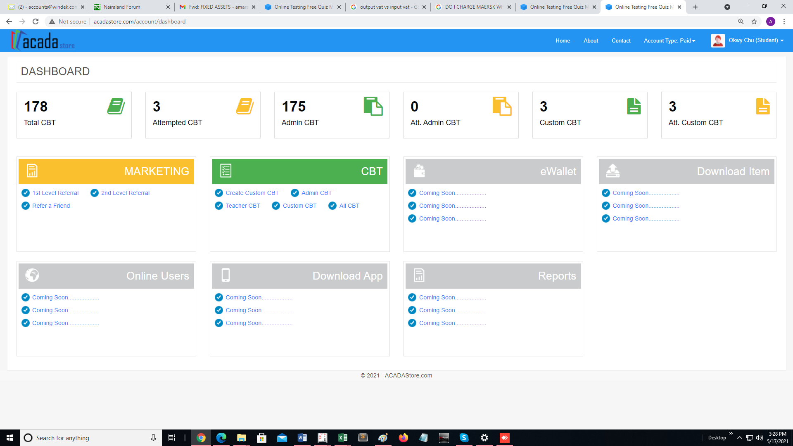

From the teacher dashboard, click CREAT CUSTOM CBT

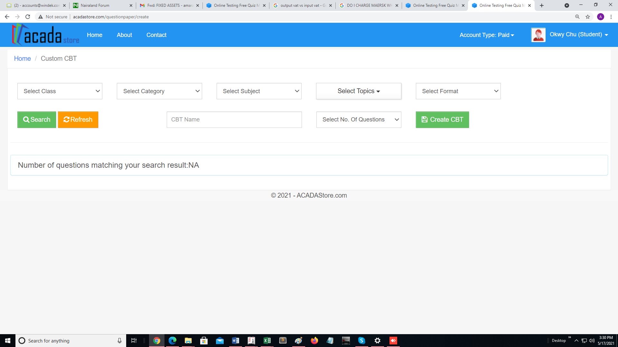

He selects the parameters and clicks on CREATE CBT

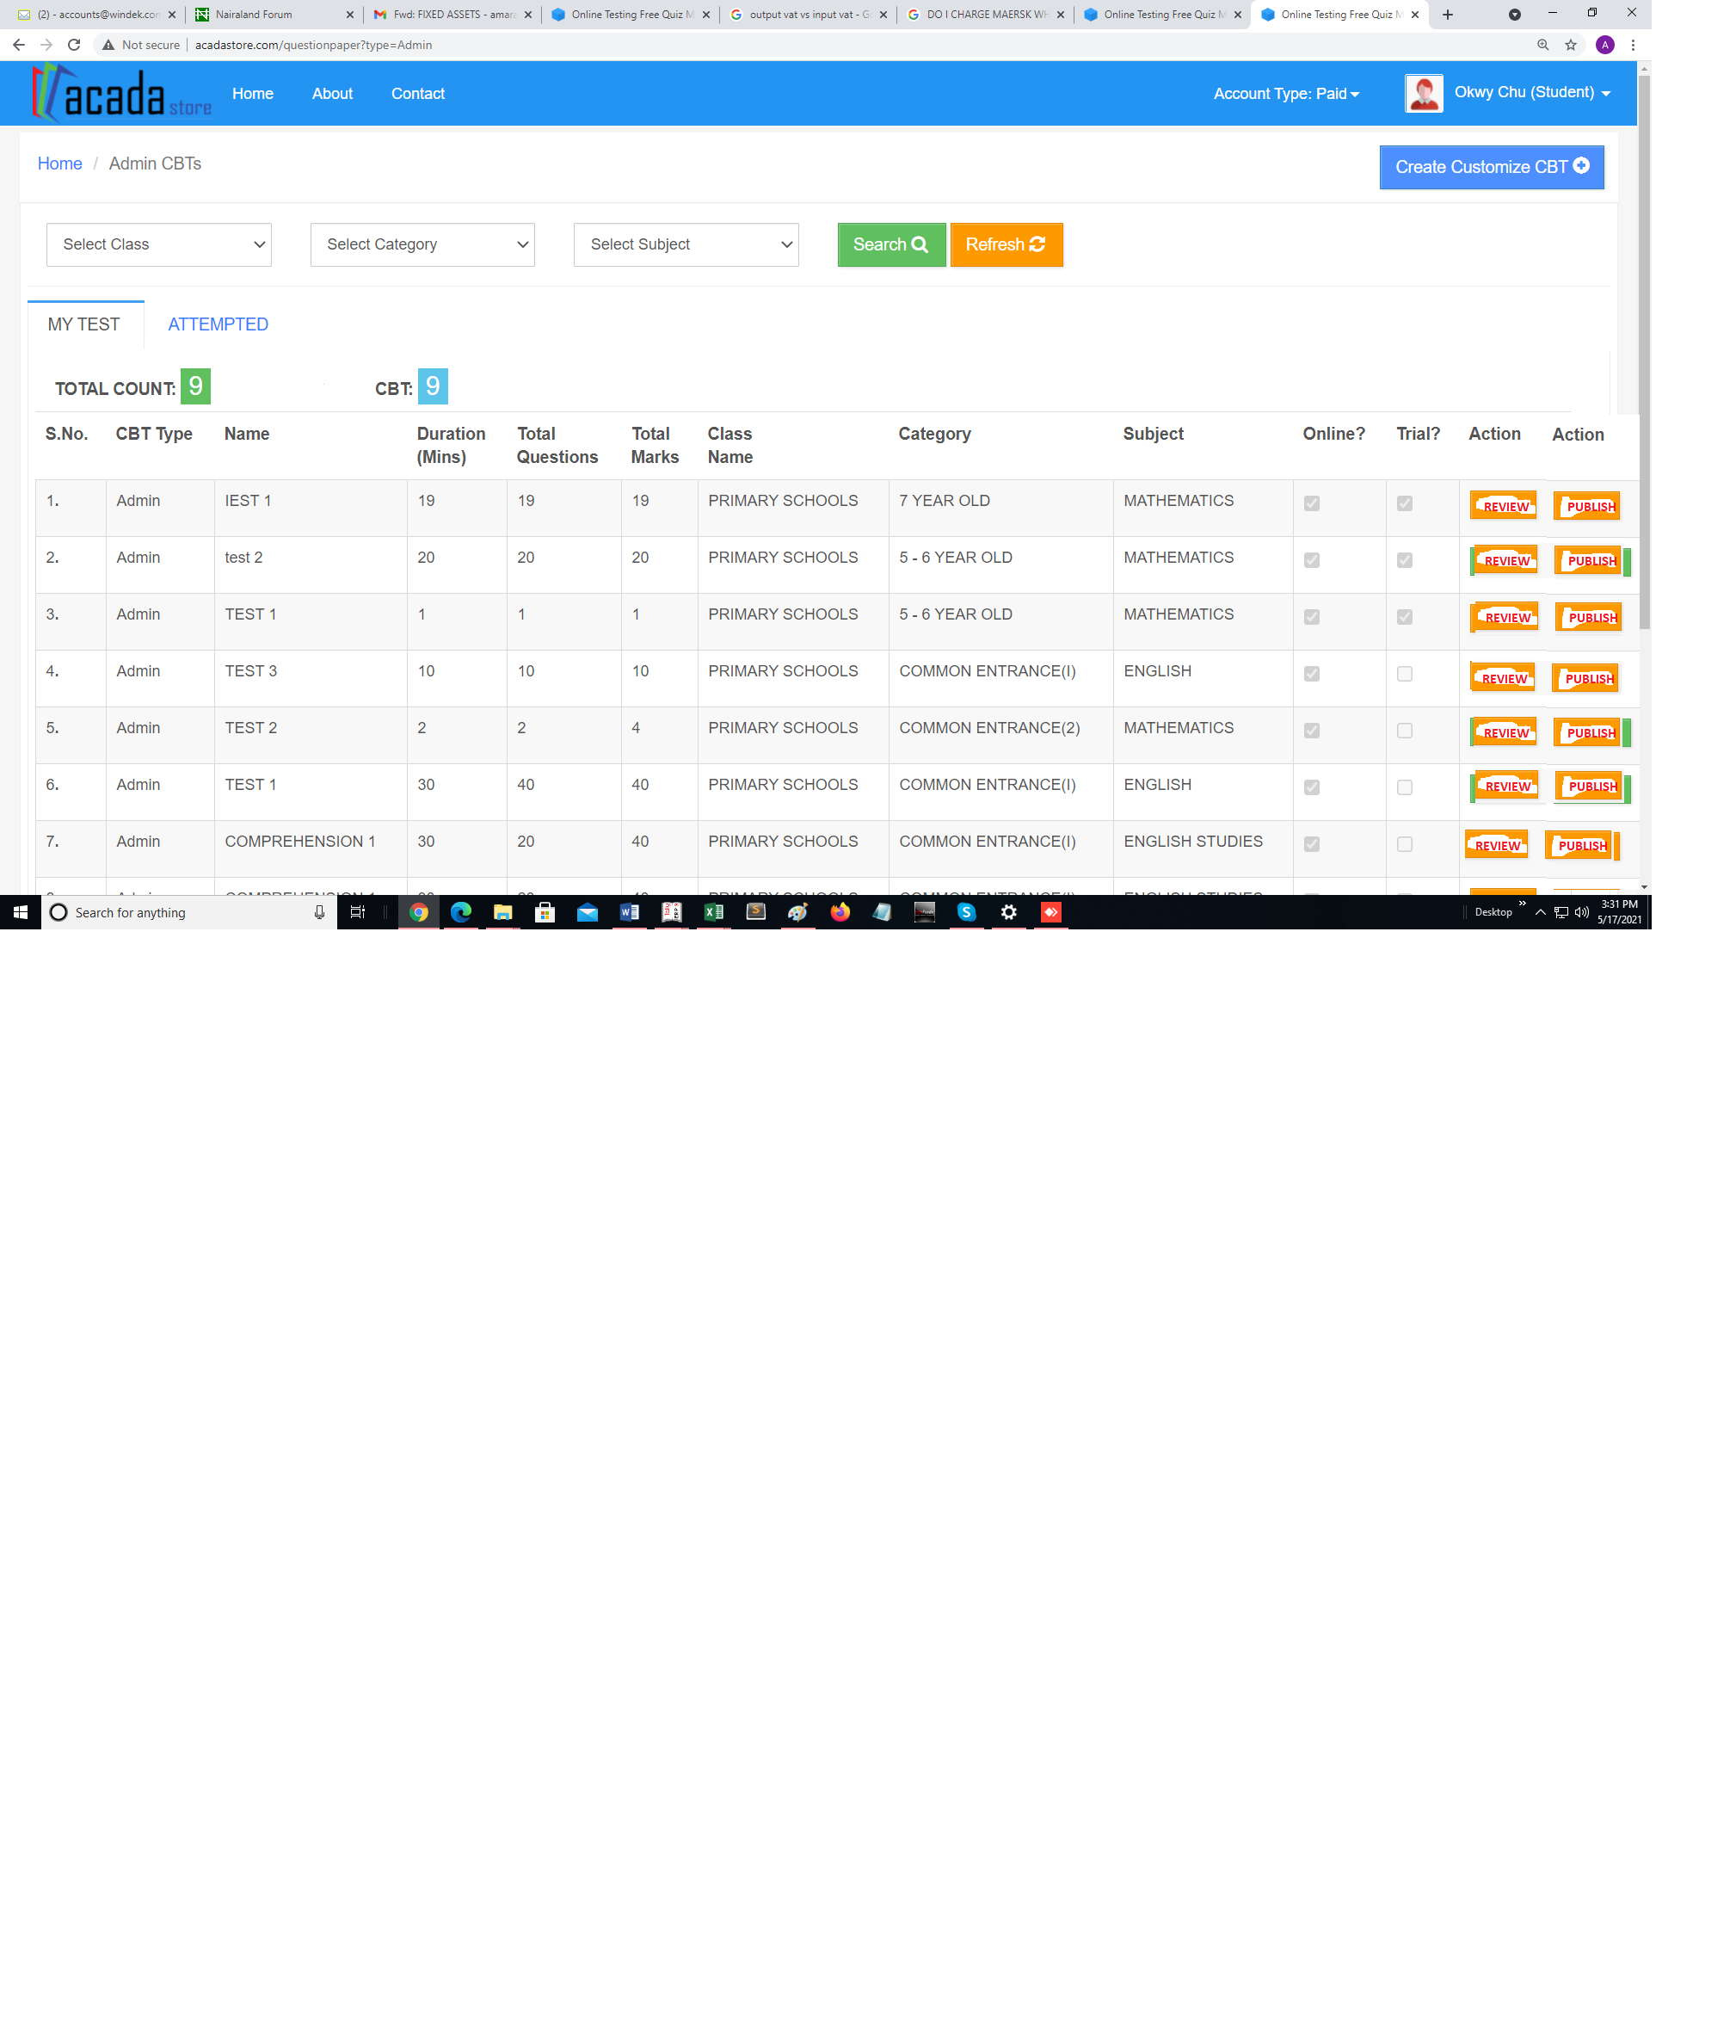

The cbt is created and presented in the tabukar format above. This is just to explain what I have in mind. You can see the REVIEW and PUBLISH button. When the REVIEW button is clicked, the solution page opens one at a time where he reviews each question and removes any he does not want in that cbt list. Finally he saves and the PUBLISHE, that is he can now send it to his targeted users